Final Report: DocSpot – Seamless Appointment Booking for Health

1. INTRODUCTION
1.1 Project Overview
DocSpot is a web-based platform that streamlines the process of booking medical appointments. It enables patients to search for doctors, check real-time availability, and schedule appointments seamlessly. The system also provides healthcare providers with tools to manage schedules and patient bookings efficiently.

1.2 Purpose
The purpose of DocSpot is to:
- Eliminate manual appointment scheduling.
- Provide patients with transparency over doctor availability and specialties.
- Reduce administrative workloads for clinics.
- Offer secure and user-friendly appointment management.

2. IDEATION PHASE
2.1 Problem Statement
Traditional healthcare appointment booking methods involve phone calls, long wait times, and manual record-keeping, causing inefficiency and patient frustration. There’s a lack of accessible digital platforms to simplify this process for both patients and healthcare providers.

2.2 Empathy Map Canvas
Does | Feels
Calls clinic to book appointments. | Frustrated by delays.
Searches online for doctor info. | Anxious about missing care.

2.3 Brainstorming
Ideas generated included:
- Search doctors by specialty or location.
- View real-time doctor availability.
- Book or reschedule appointments online.
- Admin dashboard for clinics to manage appointments.
- SMS/email reminders.
- Integration with digital health records.

3. REQUIREMENT ANALYSIS
3.1 Customer Journey Map
Stage | User Action | Pain Points | Opportunities
Search | Looks for doctor info online. | Information scattered across sites. | Single platform for doctor profiles.
Booking | Calls clinic to book slot. | Long wait times. | Online booking in real time.
Confirmation | Waits for manual confirmation. | No clarity on slot availability. | Instant confirmation.

3.2 Solution Requirement
- User authentication and authorization.
- Doctor listing with specialties and availability.
- Secure booking and appointment management.
- Admin dashboard for managing doctors and schedules.
- Notifications for appointments.

3.3 Data Flow Diagram
(Insert your DFD here as an image or diagram in Word.)
Example (textual):
- User → Auth Service → Token Issued
- User → Doctor Service → Doctor List
- User → Appointment Service → Book Appointment
- Admin → Dashboard → Manage Doctors/Appointments

3.4 Technology Stack
- Frontend: React.js, Tailwind CSS
- Backend: Node.js, Express.js
- Database: MongoDB, Mongoose
- Testing: Jest, Mocha, Chai
- API Communication: RESTful APIs with Axios

4. PROJECT DESIGN
4.1 Problem Solution Fit
Problem: Manual appointment systems are slow and inconvenient for patients and providers.
Solution: DocSpot offers a digital platform that enables online doctor discovery, real-time availability, and seamless appointment booking, solving inefficiency and user frustration.

4.2 Proposed Solution
DocSpot provides:
- Searchable doctor directory.
- Transparent time slots for booking.
- Online booking and rescheduling.
- Admin tools for managing doctors and appointments.
- Secure user data handling with JWT authentication.
- Scalable, modern tech architecture.

4.3 Solution Architecture
(Insert your solution architecture diagram here in Word, or replace this placeholder with a textual explanation.)
- Frontend (React): UI components, routing, state management.
- Backend (Node.js/Express): APIs, auth middleware, business logic.
- Database (MongoDB): Collections for users, doctors, appointments.
- Authentication: JWT-based, secure routes.

5. PROJECT PLANNING & SCHEDULING
5.1 Project Planning
Phase | Duration | Tasks
Ideation | 1 week | Problem analysis, brainstorming.
Design & Architecture | 1 week | Wireframes, DFD, architecture diagrams.
Development | 3 weeks | Frontend & backend development.
Testing | 1 week | Functional & performance testing.

6. FUNCTIONAL AND PERFORMANCE TESTING
6.1 Performance Testing
- Backend endpoints tested using Postman for response times.
- Load testing performed with JMeter for:
  - Doctor list API
  - Appointment booking API
- Frontend performance checked with Chrome Lighthouse.

7. RESULTS
7.1 Output Screenshots
- Login Page
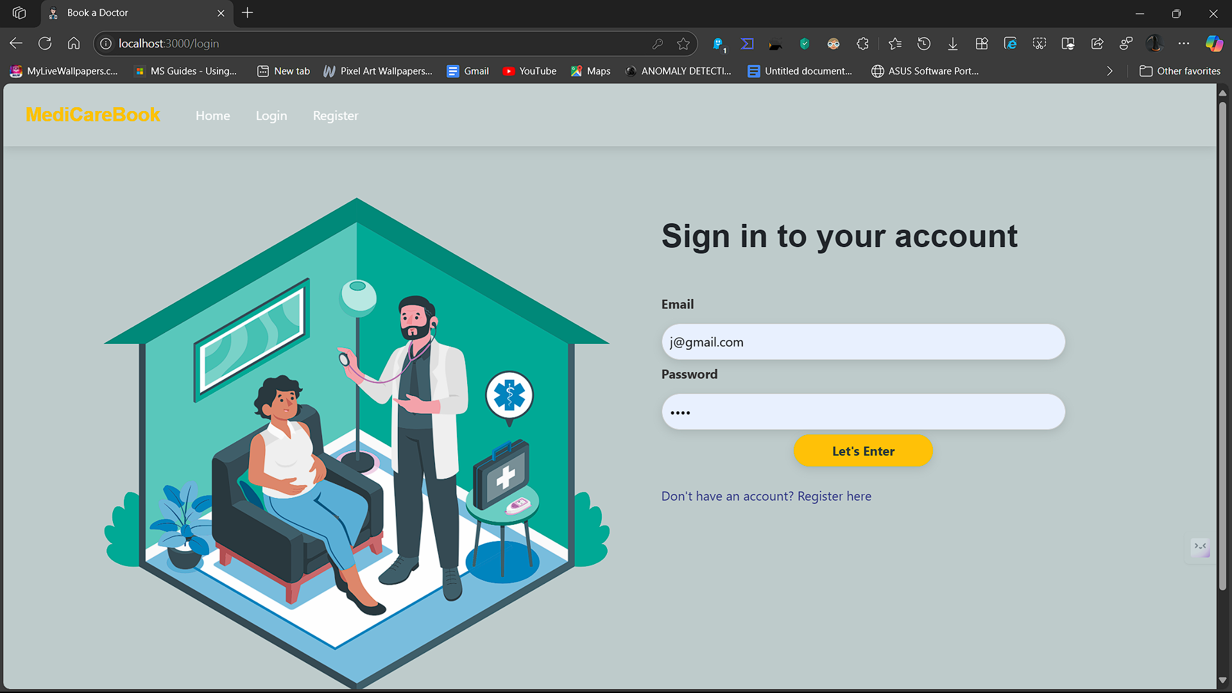
- Doctor Listings
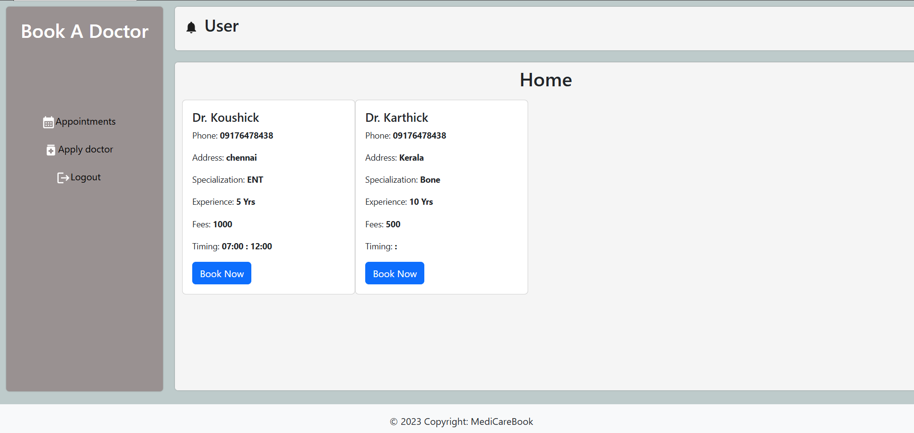

- User Dashboard
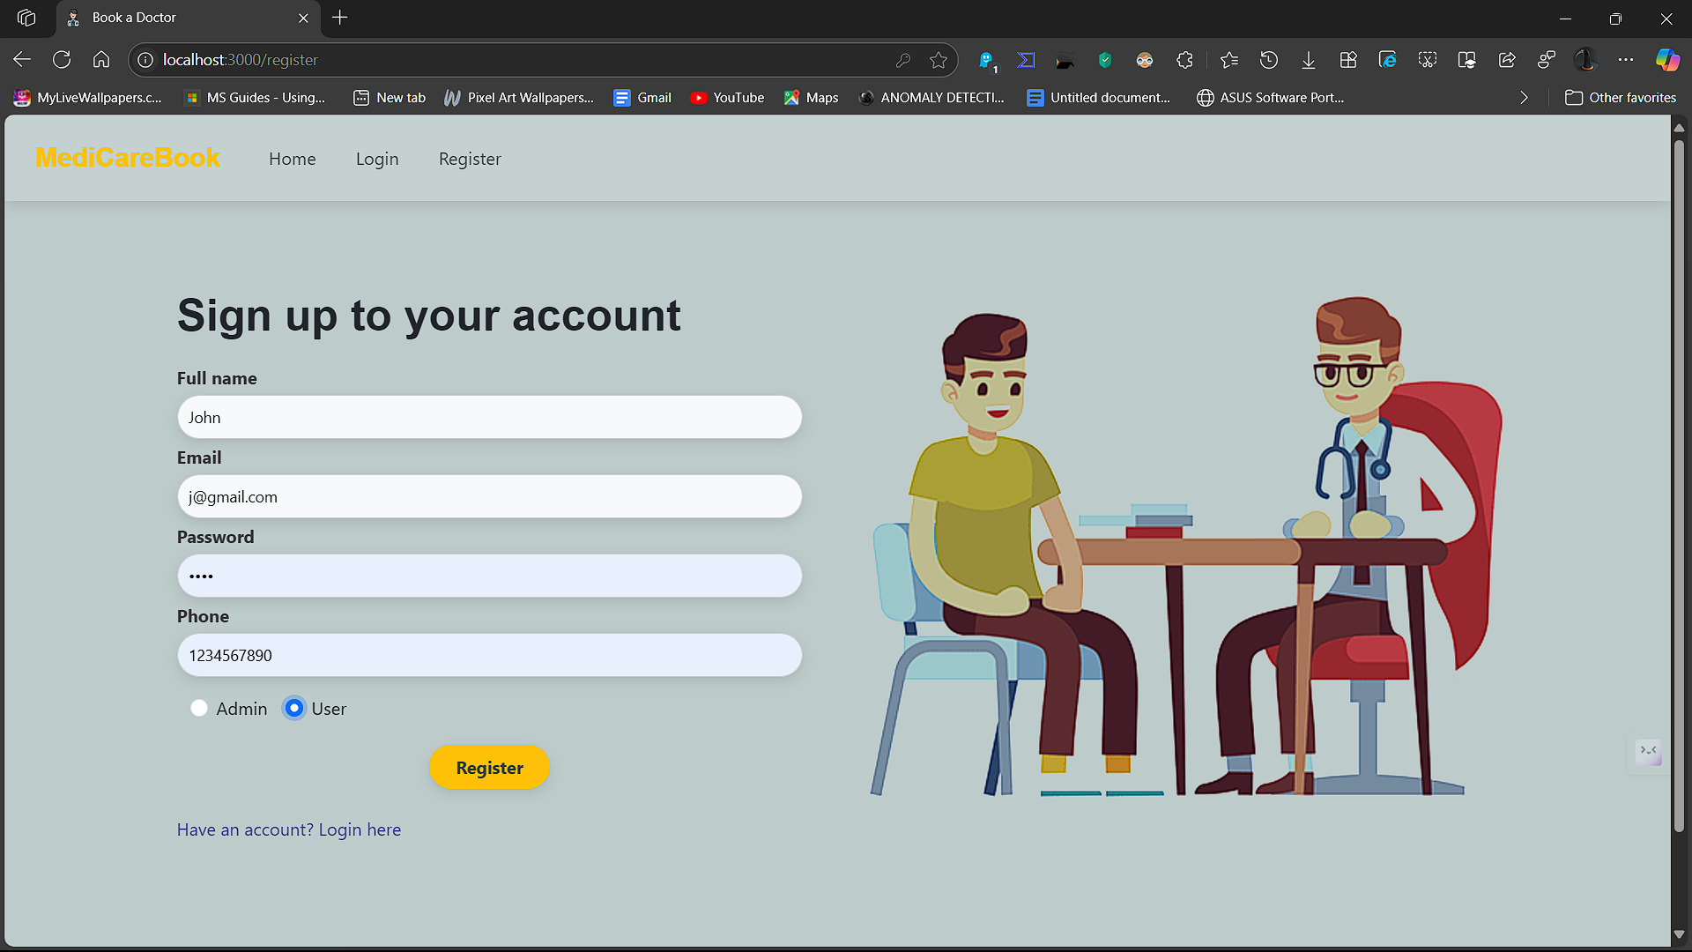
- Admin Dashboard
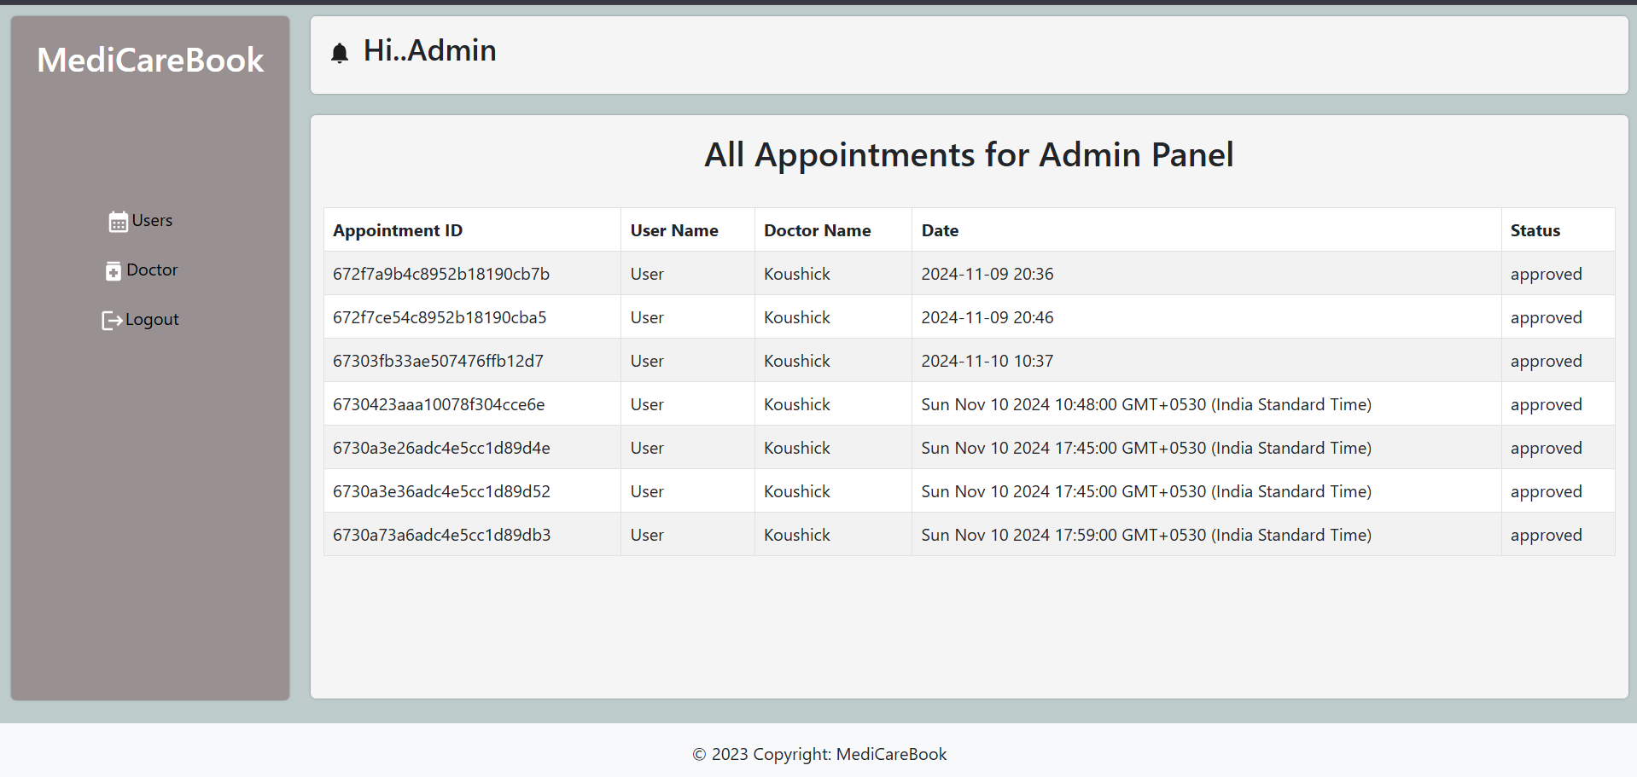

8. ADVANTAGES & DISADVANTAGES
Advantages
- Eliminates manual appointment booking.
- Reduces administrative workload.
- Provides transparency in doctor availability.
- Scalable architecture for future growth.
- Secure handling of sensitive data.
Disadvantages
- Requires internet access for patients.
- Initial learning curve for older users.
- No integrated payment gateway yet.

9. CONCLUSION
DocSpot successfully addresses inefficiencies in traditional healthcare appointment systems by providing a seamless, digital experience. The platform benefits both patients and healthcare providers by improving scheduling, transparency, and operational efficiency.

10. FUTURE SCOPE
- Integration of SMS/email reminders.
- Payment gateway for paid consultations.
- Calendar views for doctors.
- Analytics and reporting for admin dashboards.
- Mobile application development.
- Multi-language support.

11. APPENDIX
Source Code
https://github.com/Praneetha719/DocSpot-Seamless-Appointment-Booking-for-Health-
GitHub & Project Demo Link
- GitHub: https://github.com/Praneetha719/DocSpot-Seamless-Appointment-Booking-for-Health-
- Demo: https://drive.google.com/drive/folders/1Z253cXIAvsshHKtoibN7HnhcPC-Z8Lyo.

Project Team Members :
Sai Praneetha D
Sai varshitha S
Manogna D
Vedhanath Reddy M
Aveen Kumar S

